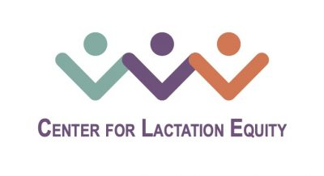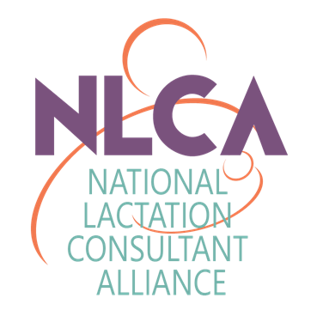
The Center for Lactation Equity Announces Two Scholarships for 2022!
NLCA’s Center for Lactation Equity (CLE) is proud to announce its 2022 Scholarship to increase access to the IBCLC® credential for persons of color* with demonstrated financial need. The two scholarships are a combined total $1124 and are broken down as follows:
- One (1) Lactation Education Resources “Lactation Consultant Training Program Enriched (LCTP)” 95+ hour course valued at $1025 (see https://www.lactationtraining.com);
- One (1) Lactation Education Resources “IBLCE Exam Review” general education course valued at $99 (see https://www.lactationtraining.com).
Applicants may apply for one or both scholarships; however, applicants will only be awarded one scholarship.
Each scholarship funds participation in the specified education program offered by Lactation Education Resources. Applicants will receive educational hours with the goal of qualifying for the IBCLC® certification exam offered by the IBLCE. The educational scholarships are intended to increase access to the IBCLC® profession and to assist candidates to reach their professional goals
Scholarship recipients will be expected to permit NLCA and CLE to recognize them publicly on our website and social media. Should the recipient not complete the educational hours for which the applicant received funding, NLCA will be fully and promptly reimbursed accordingly.
TIMELINE
Complete applications (defined as containing all supporting documentation) must be submitted by 12:00am on November 15 (note extended deadline), 2022. Scholarship awards will be announced December 15th (note new date) via direct contact and publicly on www.NLCA.us.
APPLICATION AND SUPPORTING DOCUMENTS
We invite you to apply by completing the application here.
Please note that you must have the following supporting documents ready to upload at the time you complete your application:
- A letter of recommendation (one-page double spaced maximum) from a supervisor, instructor or IBCLC® colleague

- A short statement (300 words or less) outlining why you have chosen to be an IBCLC® and how this scholarship would impact you and the communities in which you currently serve (or hope to serve).
Thank you for applying for NLCA’s Center for Lactation Equity 2022 Scholarship and thank you to Lactation Education Resources for their generosity in providing these scholarships!
Questions? Please email cle@nlca.us!
Mission:
The mission of the NLCA Center for Lactation Equity is to advance health equity by increasing families’ access to clinical lactation consultant professionals (IBCLC®) in the United States and cultivating a culture of diversity and inclusion within the IBCLC® profession.

Vision:
Equity in the field of clinical lactation care by elimination of barriers to achieving the IBCLC® credential and availability for families to access culturally appropriate care from those in their communities.

*CLE uses terms as recommended by the Bias-Free Language Guidelines set forth by the American Psychological Association. https://apastyle.apa.org/style-grammar-guidelines/bias-free-language

